Automated Casting Defect Detection
Findings Report
Binary CNN classification of casting products — custom CNN vs. Xception transfer learning

1. Executive Summary
This project builds an automated visual-inspection system that classifies images of cast metal components (e.g. pump impellers) as Non-defective (0) or Defective (1), using a Convolutional Neural Network. Two models were built and compared on a held-out test set of 715 images: a custom CNN trained from scratch, and a transfer-learning model built on Xception (ImageNet weights, frozen base).
The custom CNN reached 84.1% test accuracy. The Xception transfer-learning model reached 98.7% test accuracy and cut false negatives — defective parts wrongly passed as good — from 29 down to 6. Xception is the recommended model for production deployment.
Model | Test Accuracy | Precision (Defective) | Recall (Defective) | False Negatives
Custom CNN | 84.1% | 83.3% | 93.6% | 29 / 453
Xception (transfer) | 98.7% | 99.3% | 98.7% | 6 / 453

2. Dataset
Dataset: Casting Product Image Data for Quality Inspection (Kaggle). Images of a submersible pump impeller casting, labeled ok_front (non-defective, label 0) and def_front (defective, label 1).
Split | Non-defective (ok_front) | Defective (def_front) | Total
Train (raw folder, before val split) | 2,875 | 3,758 | 6,633
Test (held out) | 262 | 453 | 715
The training folder was further split 80/20 into training (5,307 images) and validation (1,326 images) subsets. The test folder was never used for training or validation.
The dataset is moderately imbalanced toward the defective class (56.7% of training images are defective). This is reflected in both models' higher recall than precision on the defective class, and was not corrected for with class weighting in either model — a candidate improvement noted in Section 6.
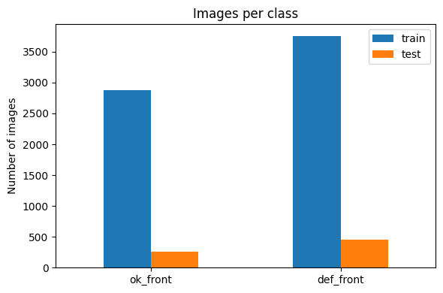
Figure 1. Image counts per class, train vs. test.
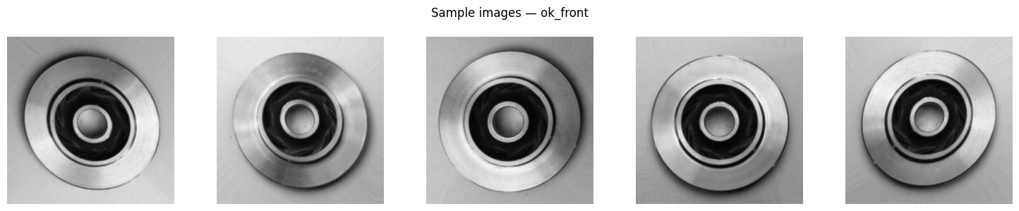
Figure 2. Sample non-defective (ok_front) images.

3. Data Preparation & Augmentation
- All images resized to 224×224 and pixel values rescaled to the 0–1 range inside the model graph.
- Training data augmented with horizontal flip, ±5% rotation, ±10% zoom, ±5% translation, and ±10% contrast adjustment — applied only to the training split, never to validation or test images.
- Augmentation and rescaling are implemented as model layers, so the same saved .keras file handles preprocessing consistently at inference time.

4. Model Architectures

4.1 Custom CNN
Three convolution blocks (32 → 64 → 128 filters, 3×3 kernels, ReLU, max-pooling after each), followed by global average pooling, dropout (0.40), a 64-unit dense layer, dropout (0.30), and a single sigmoid output neuron. 101,569 trainable parameters.

4.2 Xception Transfer Learning
Xception convolutional base (ImageNet weights, frozen) with a custom head: global average pooling, dropout (0.40), a 64-unit dense layer, dropout (0.30), and a sigmoid output. 20,992,681 total parameters, of which only 131,201 are trainable (the head) — the pretrained feature extractor is reused as-is.

4.3 Training Configuration (both models)
Setting | Value
Optimizer | Adam, initial learning rate 0.001
Loss | Binary cross-entropy
Batch size | 32
Callbacks | Early stopping (patience 5/4, monitor val_loss, restore best weights), ReduceLROnPlateau (factor 0.5), ModelCheckpoint (save best val_loss)
Epochs (budget) | Custom CNN: 25 · Xception: 15

5. Training Results

5.1 Custom CNN
Training ran for 19 of the 25 budgeted epochs before early stopping triggered. Accuracy climbed steadily but validation accuracy was volatile epoch-to-epoch (e.g. dropping to 68.3% at epoch 16 before recovering), indicating the smaller from-scratch network is more sensitive to the mild augmentation and to the learning-rate schedule. The gap between training and validation curves stayed fairly close, so this reads as a model still under-fitting somewhat within the epoch budget, rather than classic overfitting.
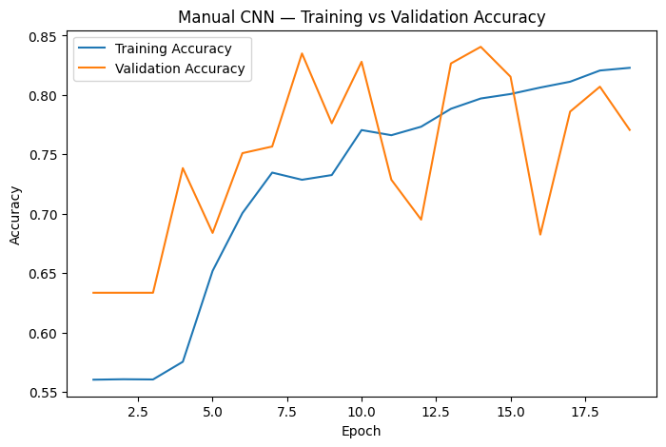
Figure 3. Custom CNN — training vs. validation accuracy.
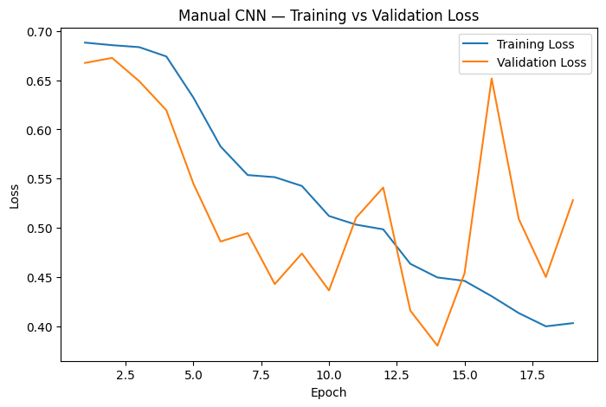
Figure 4. Custom CNN — training vs. validation loss.

5.2 Xception Transfer Learning
Training used the full 15-epoch budget (early stopping never triggered). Validation accuracy exceeded training accuracy throughout, which is expected here since dropout is active during training but not validation, and the frozen ImageNet features generalize well immediately. Both curves rise smoothly with no sign of overfitting inside this budget.
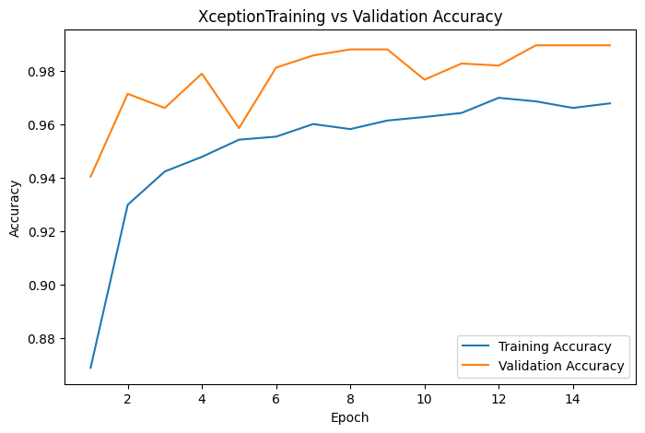
Figure 5. Xception — training vs. validation accuracy.
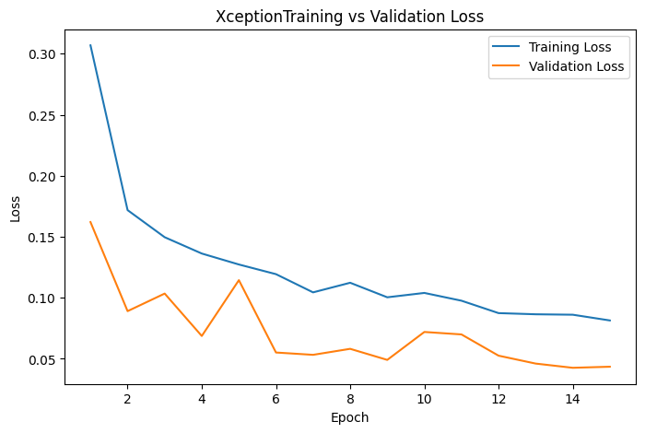
Figure 6. Xception — training vs. validation loss.

6. Test Set Evaluation

6.1 Custom CNN
Class | Precision | Recall | F1-score | Support
Non-defective | 0.86 | 0.68 | 0.76 | 262
Defective | 0.83 | 0.94 | 0.88 | 453
Accuracy |  |  | 0.84 | 715
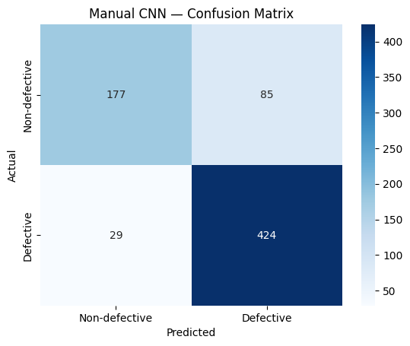
Figure 7. Custom CNN — confusion matrix (test set).
177 true negatives, 85 false positives, 29 false negatives, 424 true positives. Recall on non-defective parts (68%) is the weak point: nearly 1 in 3 good parts is wrongly flagged as defective, which would create unnecessary manual-review workload on the line.

6.2 Xception Transfer Learning
Class | Precision | Recall | F1-score | Support
Non-defective | 0.98 | 0.99 | 0.98 | 262
Defective | 0.99 | 0.99 | 0.99 | 453
Accuracy |  |  | 0.99 | 715
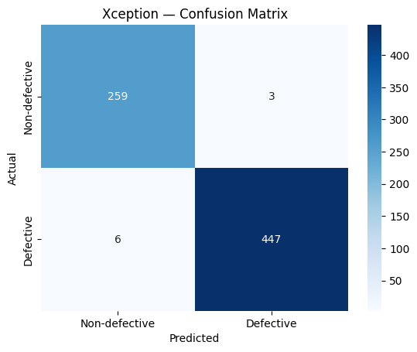
Figure 8. Xception — confusion matrix (test set).
259 true negatives, 3 false positives, 6 false negatives, 447 true positives. Both error types are small and balanced, with false negatives (defective parts missed) more than four times lower than the custom CNN's.

7. False-Negative Analysis
False negatives are the highest-priority error in this application — each one is a defective part that the system would allow to pass and potentially reach a customer. The custom CNN missed 29 of 453 defective test images (6.4% miss rate); Xception missed 6 of 453 (1.3% miss rate).
This gap is the main reason to prefer Xception for deployment: at the default 0.50 threshold, it is roughly 5x less likely to let a defective part through than the custom CNN, at a comparable false-positive cost (3 vs. 85 good parts wrongly rejected).

8. Predictions on Unseen Sample Images
Five held-out test images (2 non-defective, 3 defective, not used in training or validation) were passed through both models for a qualitative check.
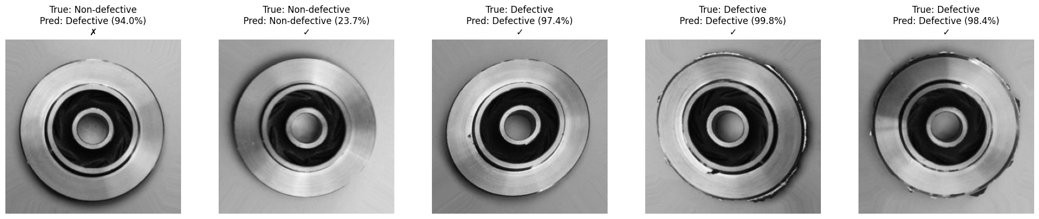
Figure 9. Custom CNN predictions on five unseen sample images.
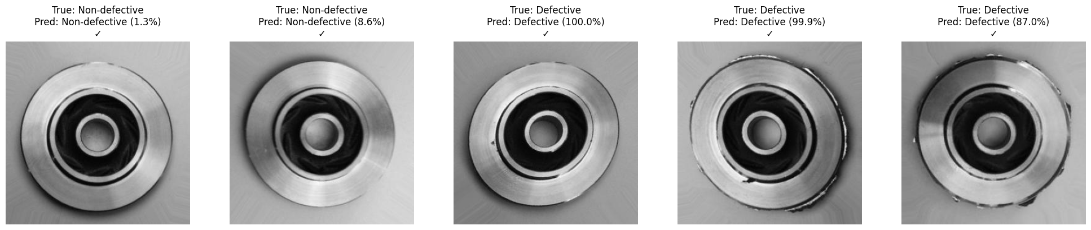
Figure 10. Xception predictions on the same five unseen sample images.
Xception classified all five samples correctly, in every case with at least 87% confidence. The custom CNN correctly identified the three defective samples and one of the two non-defective samples, but confidently misclassified one non-defective part as defective (94.0% probability) — an example of the false-positive behaviour already visible in its confusion matrix, and consistent with the wider validation-accuracy volatility seen in Figure 3.

9. Threshold Considerations
Both models use the default 0.50 classification threshold. Because false negatives carry a higher business cost than false positives in quality control, a lower threshold (e.g. 0.30–0.40) trades some additional false positives for fewer missed defects, and should be tuned against the actual cost of manual re-inspection versus the cost of a defective part reaching a customer. Given Xception's already low false-negative count, threshold tuning is most useful for the custom CNN if it were to be deployed instead.

10. Conclusion & Recommendation
- Both models satisfy the task's binary-classification requirements: augmentation restricted to training data, dropout, early stopping, sigmoid output, and binary cross-entropy loss.
- The custom CNN is a reasonable from-scratch baseline (84.1% accuracy) but its false-negative and false-positive rates are too high for unattended production use.
- The Xception transfer-learning model (98.7% accuracy, 1.3% false-negative rate) is the recommended model for deployment, given the strong reduction in missed defects at a similarly low false-positive cost.
- Recommended next steps: evaluate class weighting for the residual imbalance, tune the decision threshold against real inspection costs, and consider Grad-CAM visualization to confirm the model is attending to the actual defect region rather than incidental image artifacts.

11. Deliverables
Saved model files: best_manual_cnn.keras / final_manual_cnn.keras (custom CNN) and best_xception_model.keras / final_xception_model.keras (Xception). See README.md for setup and execution instructions, and the accompanying notebook for full, runnable code covering every step referenced in this report.

